**Topic 1: Bootstrap – includes (form, html, class, form group and bootstrap styling.  
  
Assignment 1**: Write code to achieve below output.

|  |  |
| --- | --- |
| Output: |  |

**Topic 2: CSS Introduction, HTML, CSS and CSS syntax**

**Assignments1**: Write CSS to achieve same output as below.

|  |  |
| --- | --- |
| Images |  |

**Topic 3: HTML Attributes, HTML Basic, HTML Blocks**

**Assignment 1**: Create a table with DIV Element and apply background-image to odd number of row internal style and do the font and border styling by calling external css

**Topic 4: New HTML Elements, HTML Formatting**

**Assignment 1**: Create a dropdown menu using dropdown menu within a navbar as displayed below:

|  |  |
| --- | --- |
| Expected output |  |

**Topic 5: HTML Introduction, html head, and html image** **Assignment 1**: Create a round corner thumbnail image with caption message as display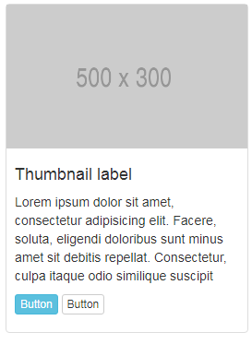

**Topic 6: HTML Layout, HTML Links, HTML Lists, HTML Tables**   
**Assignment 1**: Write code using div to achieve below output. Display of content needs to be in   
 stripes. Where first element to be clickable.  
 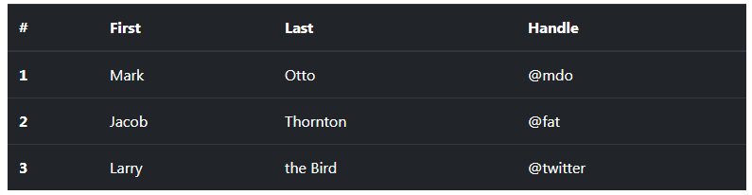

**Topic 7: HTML URL Encode**

**Assignment 1**: write code to encrypt the string message as given below.

|  |  |  |
| --- | --- | --- |
| Message | https://getbootstrap.com/docs/4.1/content/images/ | https%3A%2F%2Fgetbootstrap.com%2Fdocs%2F4.1%2Fcontent%2Fimages%2F |